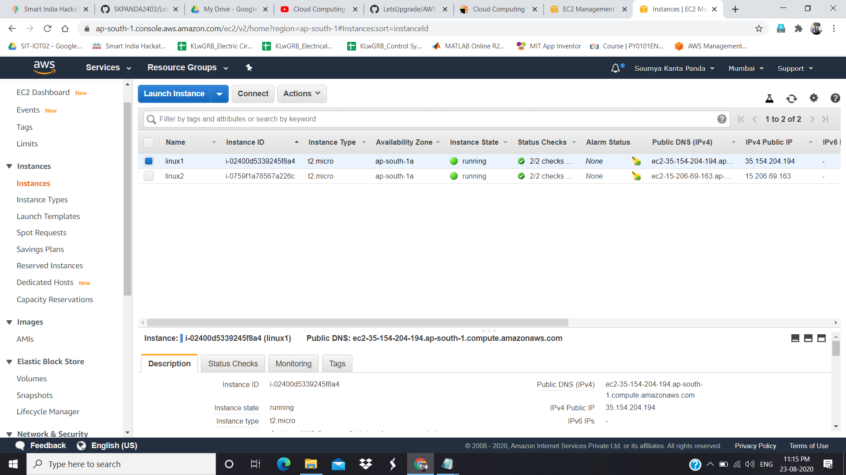

**LINUX 1 ACTIVE**

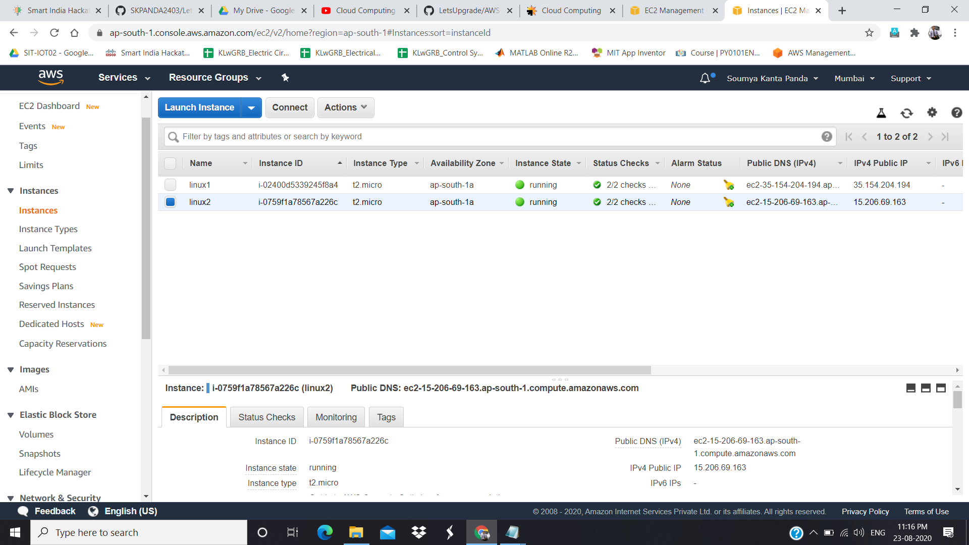

**LINUX 2 ACTIVE**

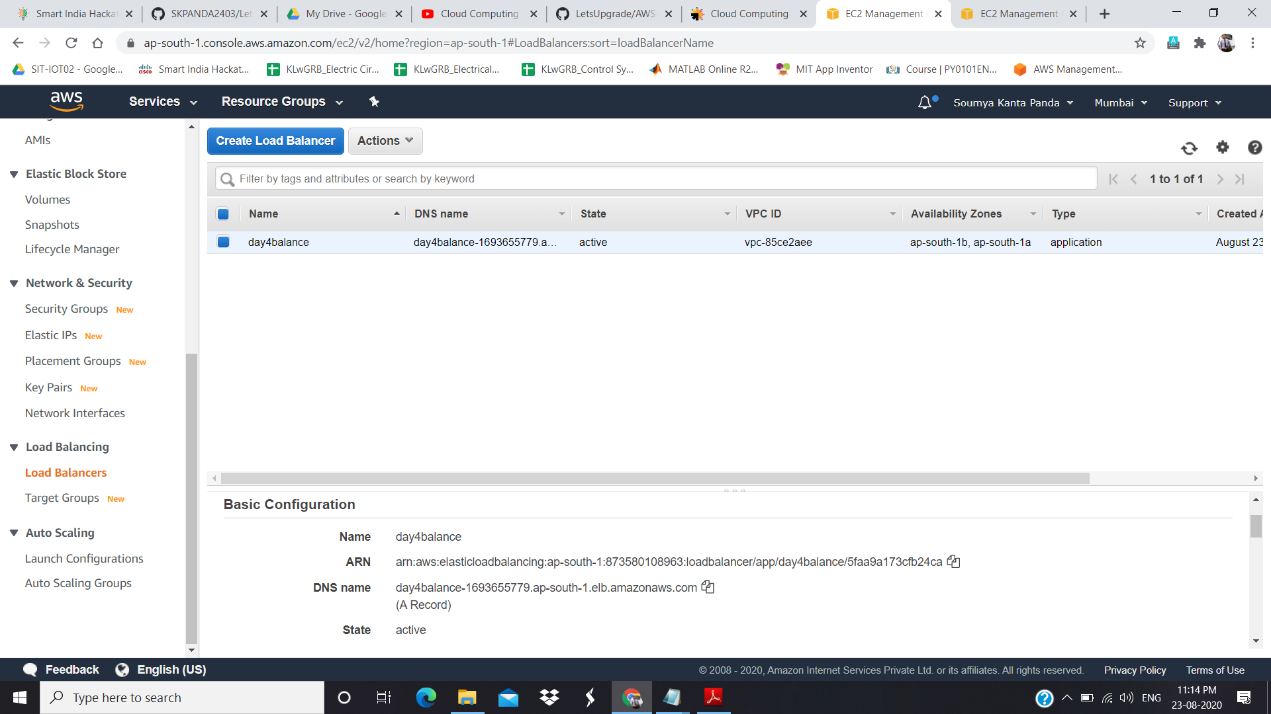

**LOAD BALANCER IN ACTIVE STATE**

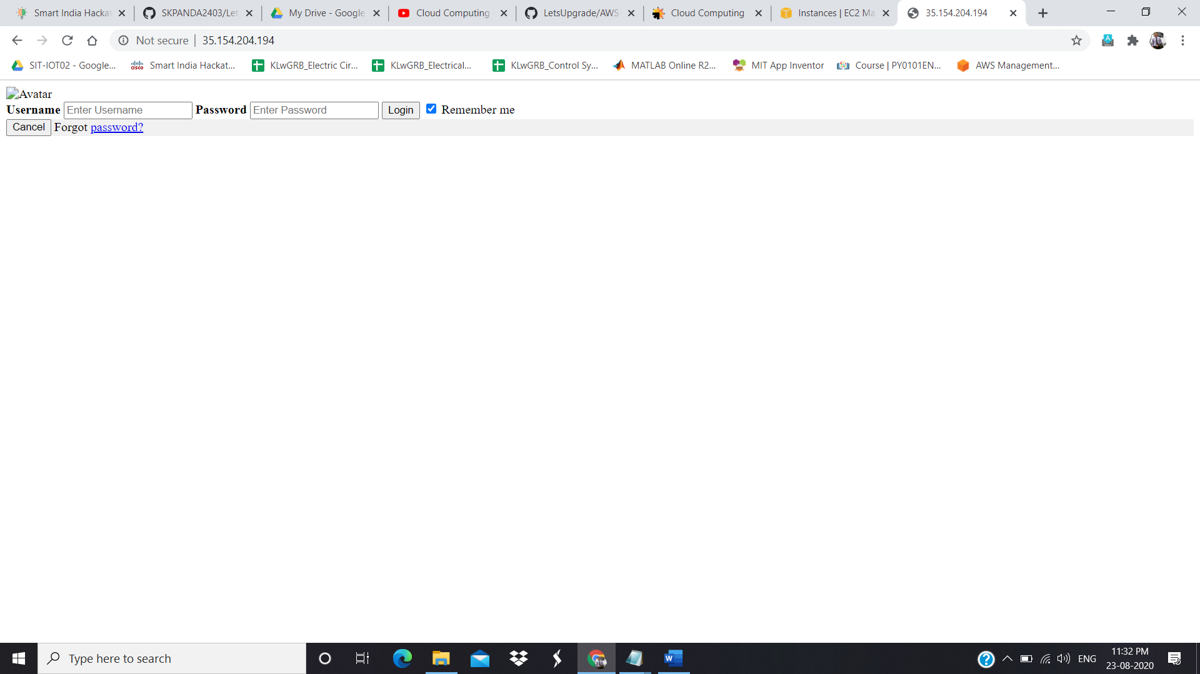

**SUCCESSFULLY HOSTED LINUX 1**

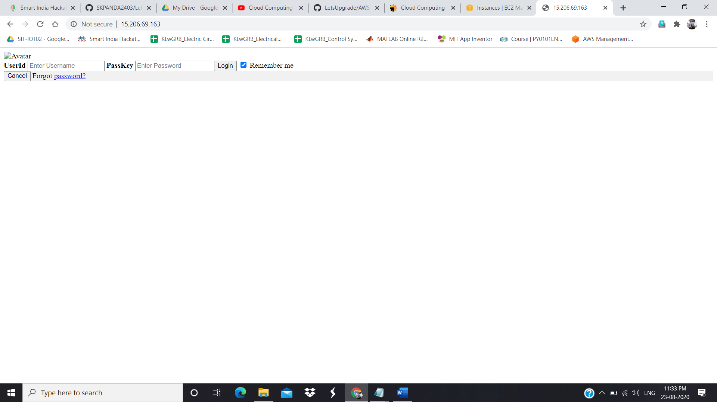

**SUCCESSFULLY HOSTED LINUX 2**

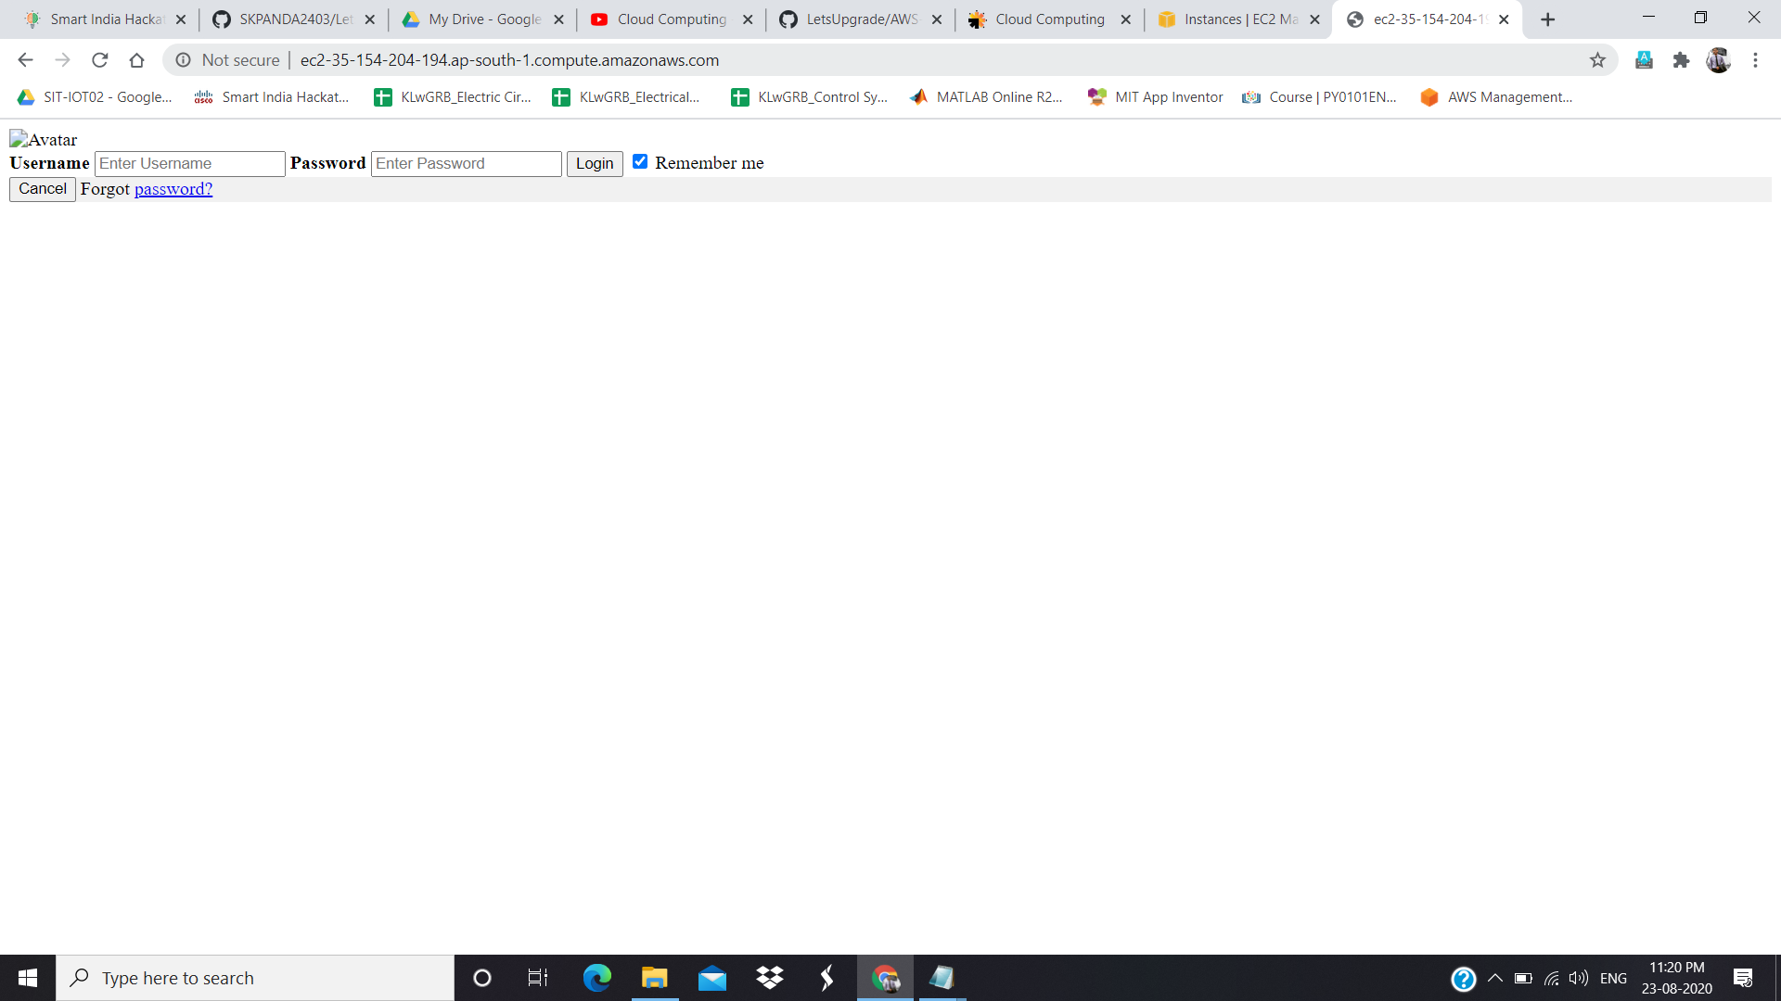

**DNS RESPONDING TO LINUX 1**

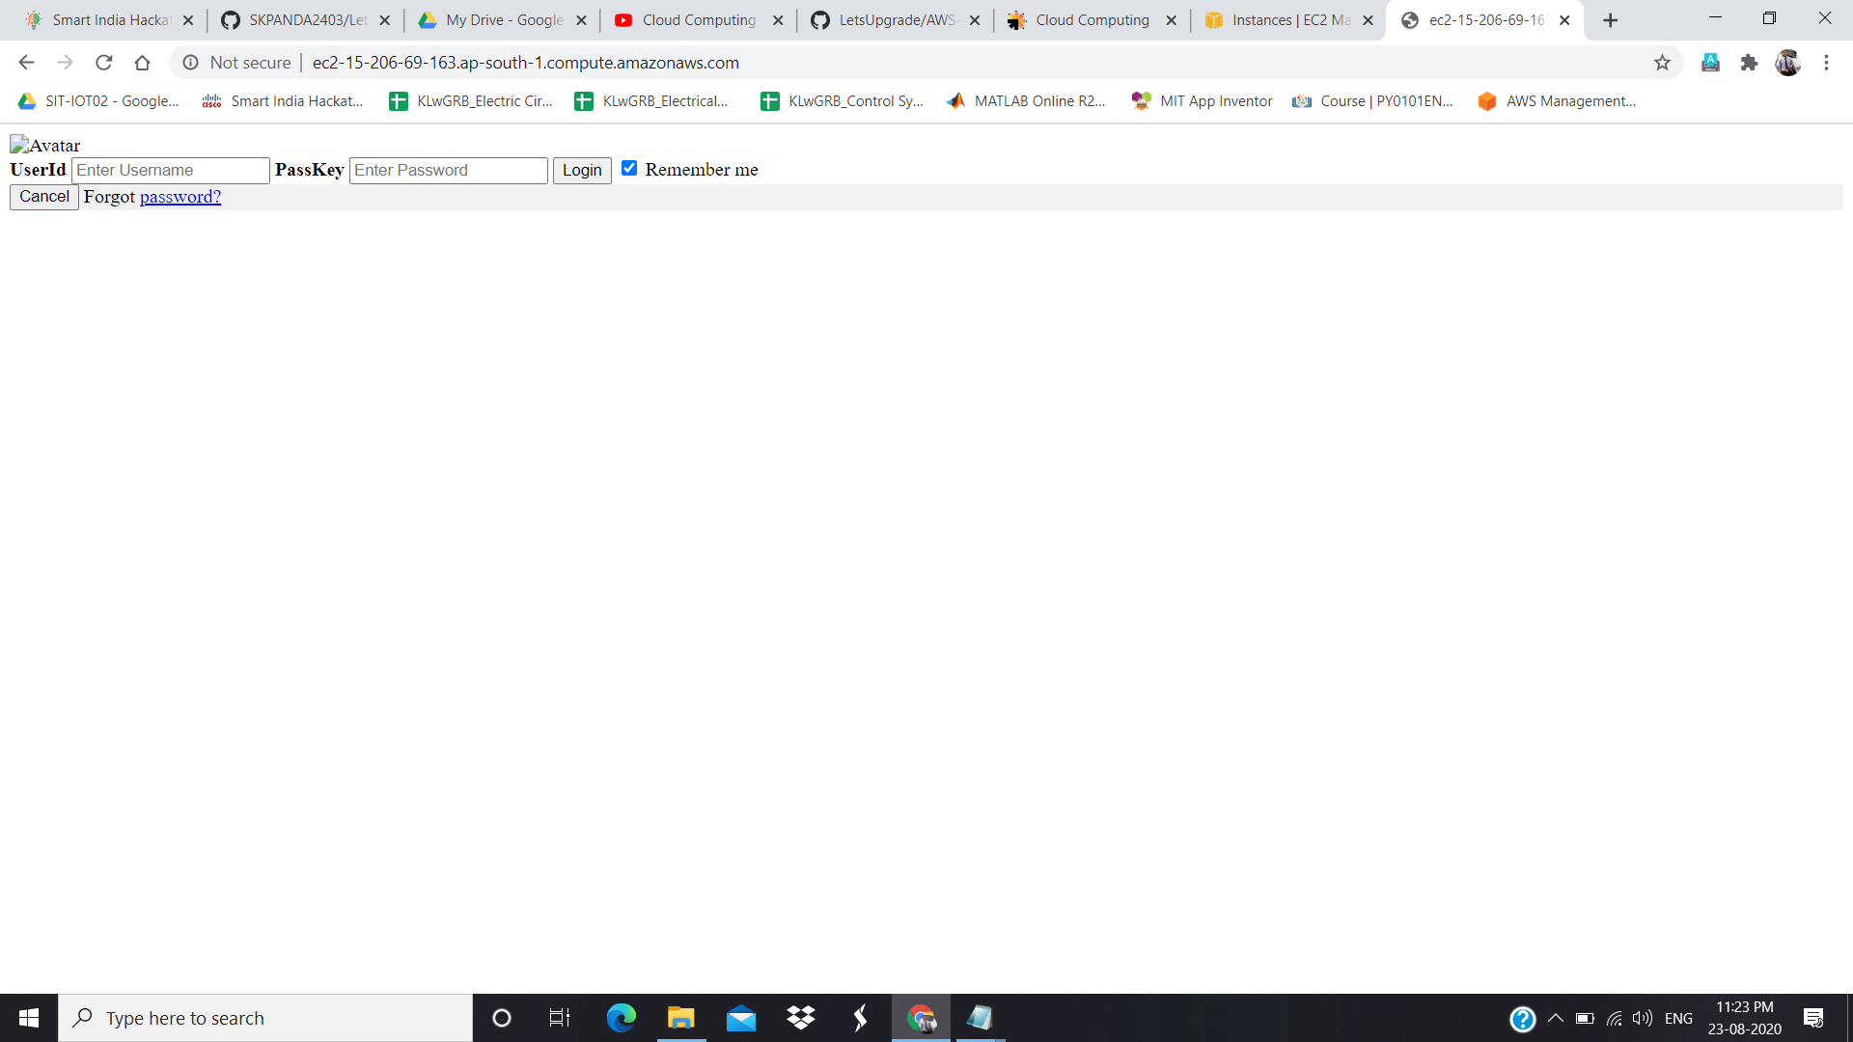

**DNS RESPONDING TO LINUX 2**